**Arraycodingquestion:**

1. FindtheLargestandSmallestElement
   * Given anarray,find thesmallestandlargestelementsinit.

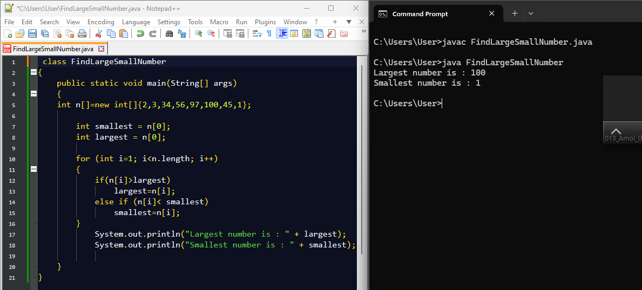

1. ReverseanArray
   * Reversethegivenarrayinplace.

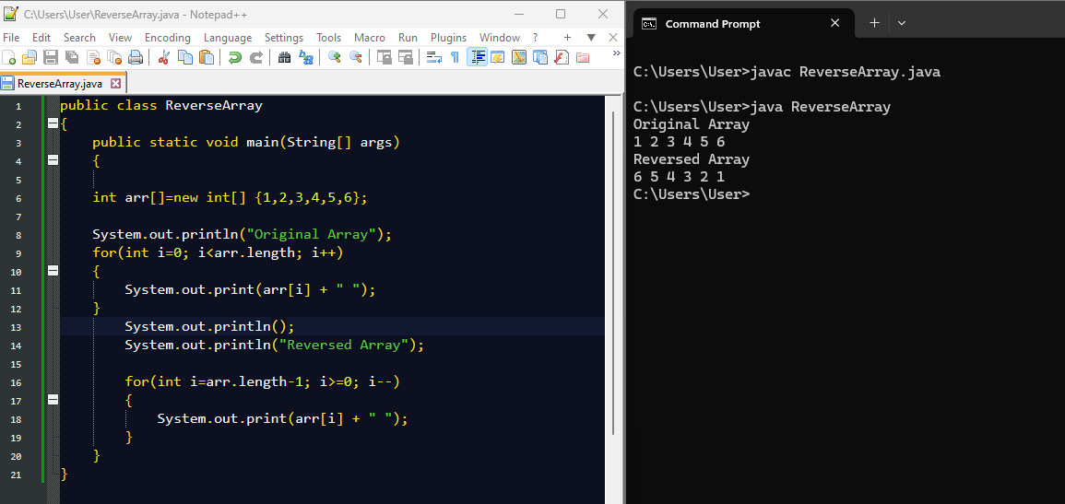

1. FindtheSecondLargest Element
   * Findthesecond-largestelementinthegivenarray.

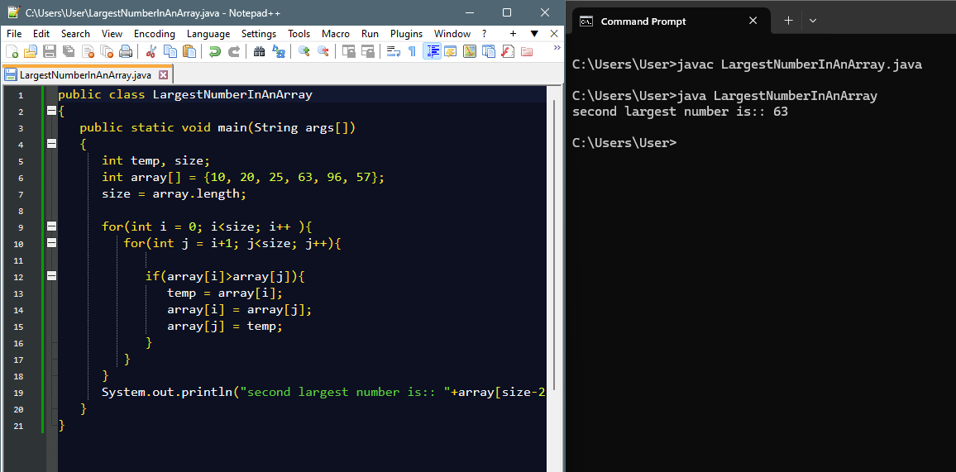

1. CountEvenandOddNumbers
   * Countthenumberofevenandoddnumbersinanarray.

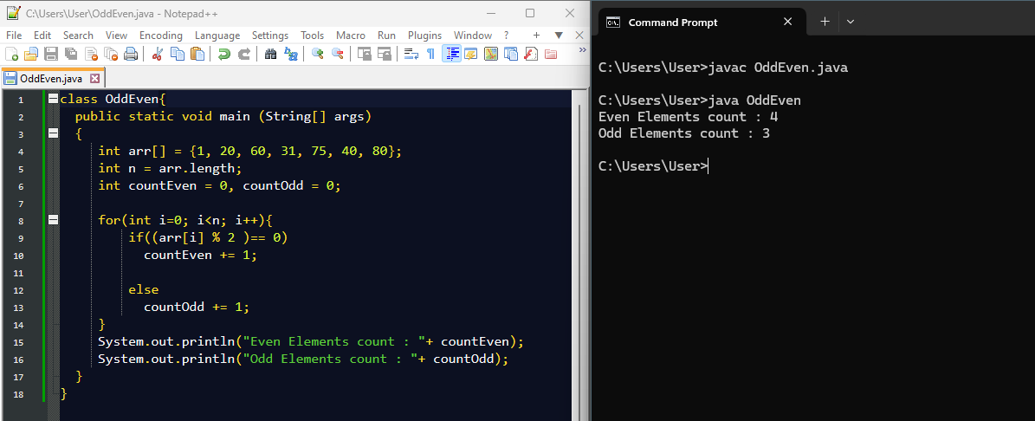

1. FindSumandAverage
   * Computethesumandaverageofallelementsinthearray.

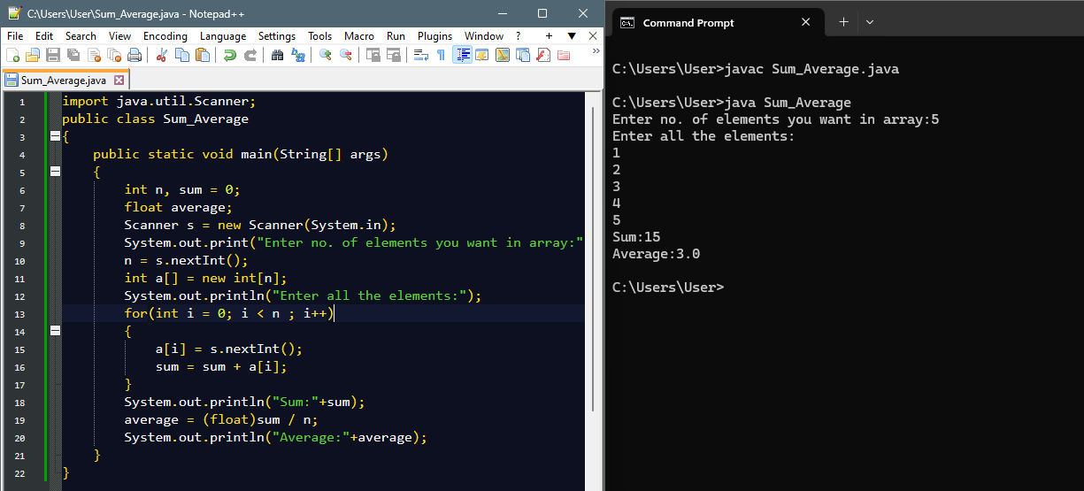

1. RemoveDuplicatesfromaSortedArray
   * Removeduplicateelementsfromasortedarraywithoutusingextraspace.
2. RotateanArray
   * Rotatethearraytotherightbykpositions.
3. MergeTwoSortedArrays
   * Mergetwosortedarraysintoasinglesortedarraywithoutusingextraspace.
4. FindMissingNumberinanArray
   * Givenanarrayofsizen-1containingnumbersfrom1ton,findthemissingnumber.
5. FindIntersectionandUnionofTwoArrays
   * Findtheintersectionandunionoftwounsortedarrays.
6. FindaSubarraywithGivenSum
   * Givenanarrayofintegers,findthesubarraythatsumstoagivenvalueS.
7. Writeaprogramtoaccept20integernumbersinasingleDimensionalArray.Findand Display the following:
   * Numberofevennumbers.
   * Numberofoddnumbers.
   * Numberofmultiplesof3
8. WriteaprogramtoacceptthemarksinPhysics,ChemistryandMathssecuredby20class students in a single Dimensional Array. Find and display the following:
   * Numberofstudentssecuring75%andaboveinaggregate.
   * Numberofstudentssecuring40%andbelowinaggregate.
9. WriteaprograminJavatoaccept20numbersinasingledimensionalarrayarr[20].Transfer and store all the even numbers in an array even[ ] and all the odd numbers in another array odd[ ]. Finally, print the elements of the even & the odd array.
10. WriteaJavaprogramtoprintallsub-arrayswith0sumpresentinagivenarrayofintegers.

Example:

Input:

nums1={1,3,-7,3,2,3,1,-3,-2,-2}

nums2={1,2,-3,4,5,6}

nums3={1,2,-2,3,4,5,6}

Output:

Sub-arrayswith0sum:[1,3,-7,3]

Sub-arrayswith0sum:[3,-7,3,2,3,1,-3,-2]

Sub-arrayswith0sum:[1,2,-3]

Sub-arrayswith0sum:[2,-2]

1. GiventwosortedarraysAandBofsizepandq,writeaJavaprogramtomergeelementsof A with B by maintaining the sorted order i.e. fill A with first p smallest elements and fill B with remaining elements.

Example:

Input:

int[]A={1,5,6,7,8,10}

int[]B={2,4,9}

Output:

SortedArrays:

A:[1,2,4,5,6,7]

B:[8,9,10]

1. WriteaJavaprogramtofindthemaximumproductoftwointegersinagivenarrayof integers.

Example:

Input:

nums={2,3,5,7,-7,5,8,-5}

Output:

Pairis(7,8),MaximumProduct:56

1. PrintaMatrix
   * Givenanmxnmatrix,printallitselementsrow-wise.

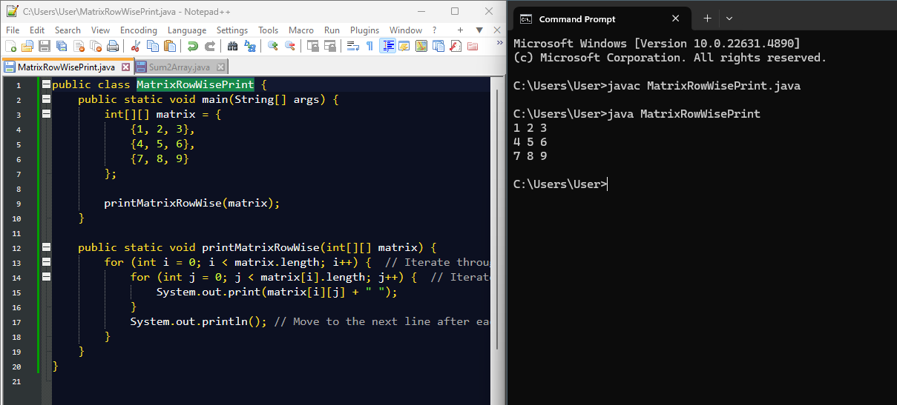

1. TransposeofaMatrix
   * Givenamatrix,returnitstranspose(swaprowsandcolumns).

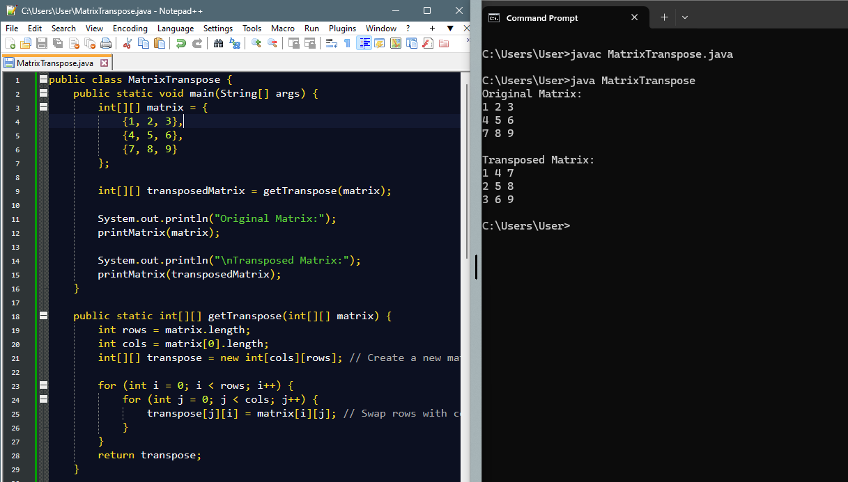

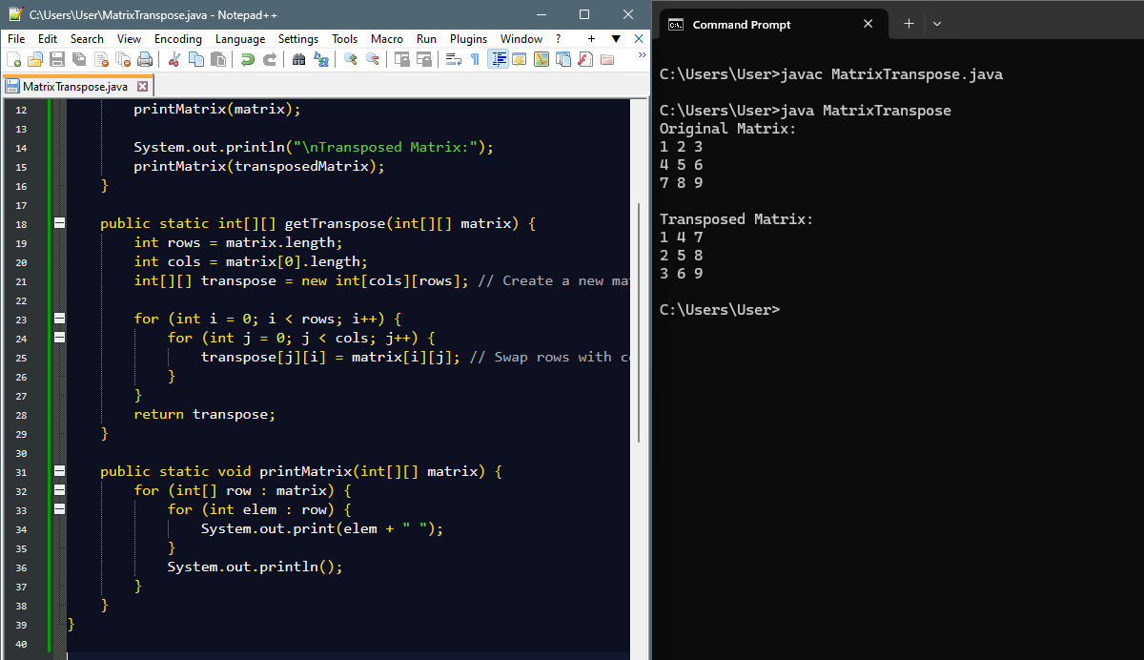

1. SumofTwoMatrices
   * Giventwomatricesofthesamesize,computetheirsum.

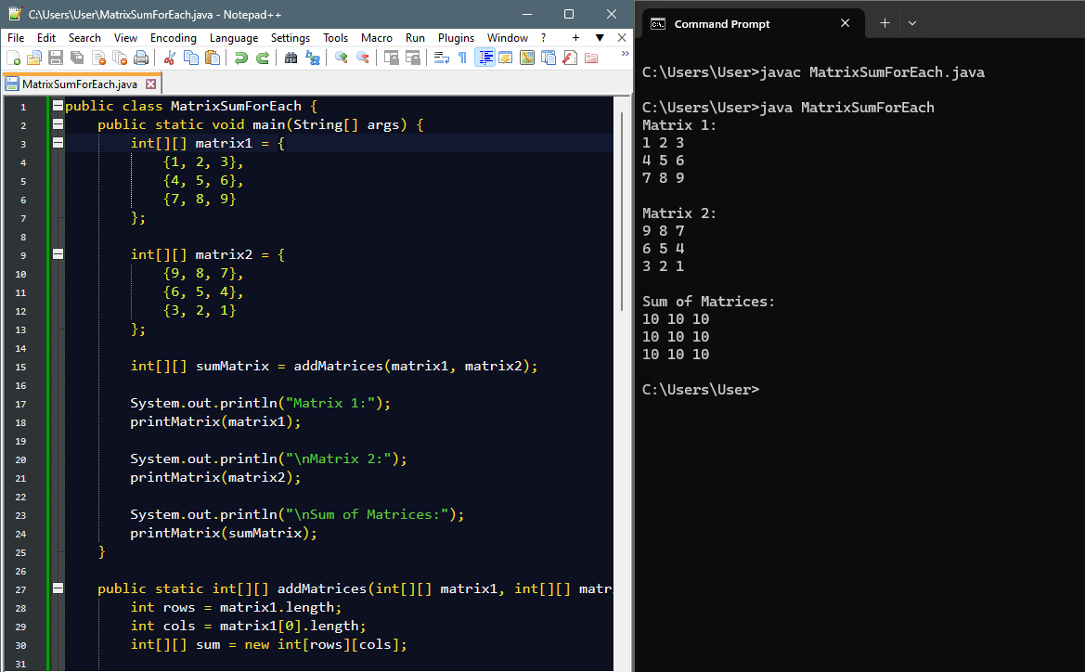

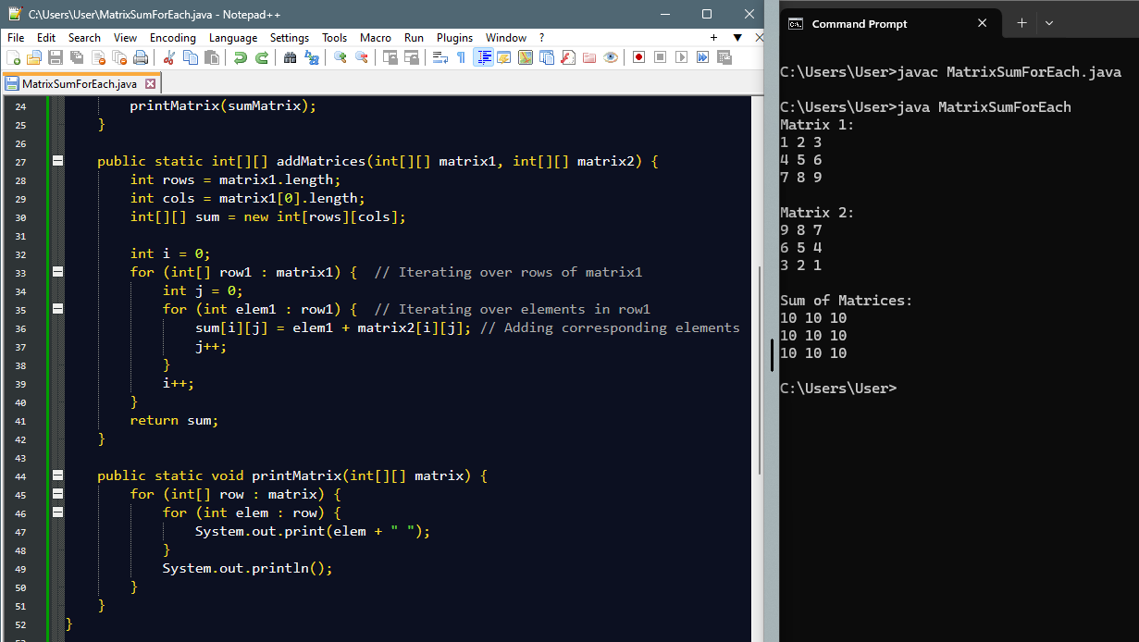

1. Row-wiseandColumn-wiseSum
   * Findthesumofeachrowandeachcolumnofagivenmatrix.

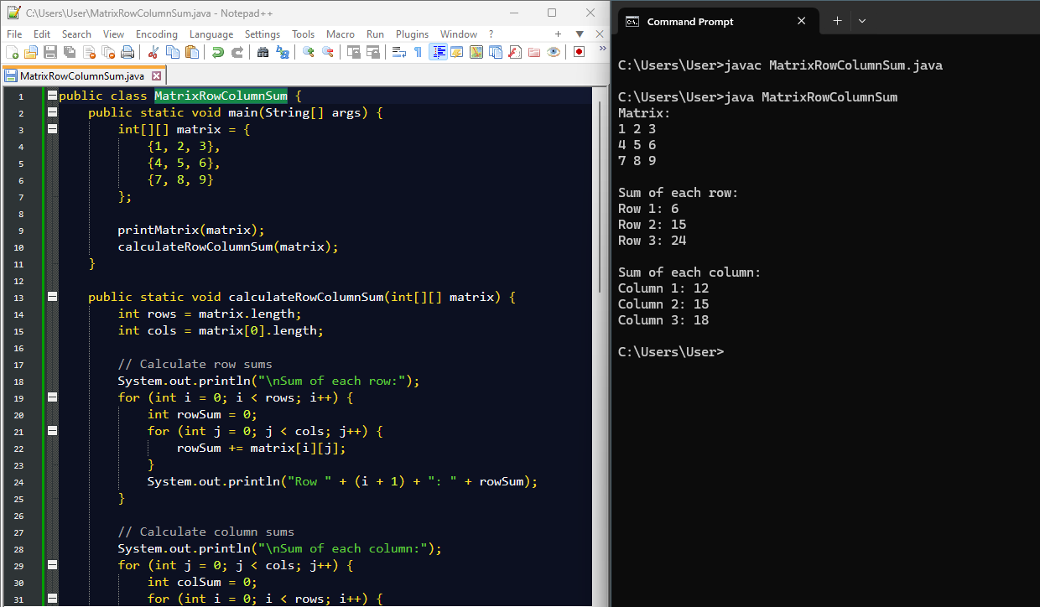

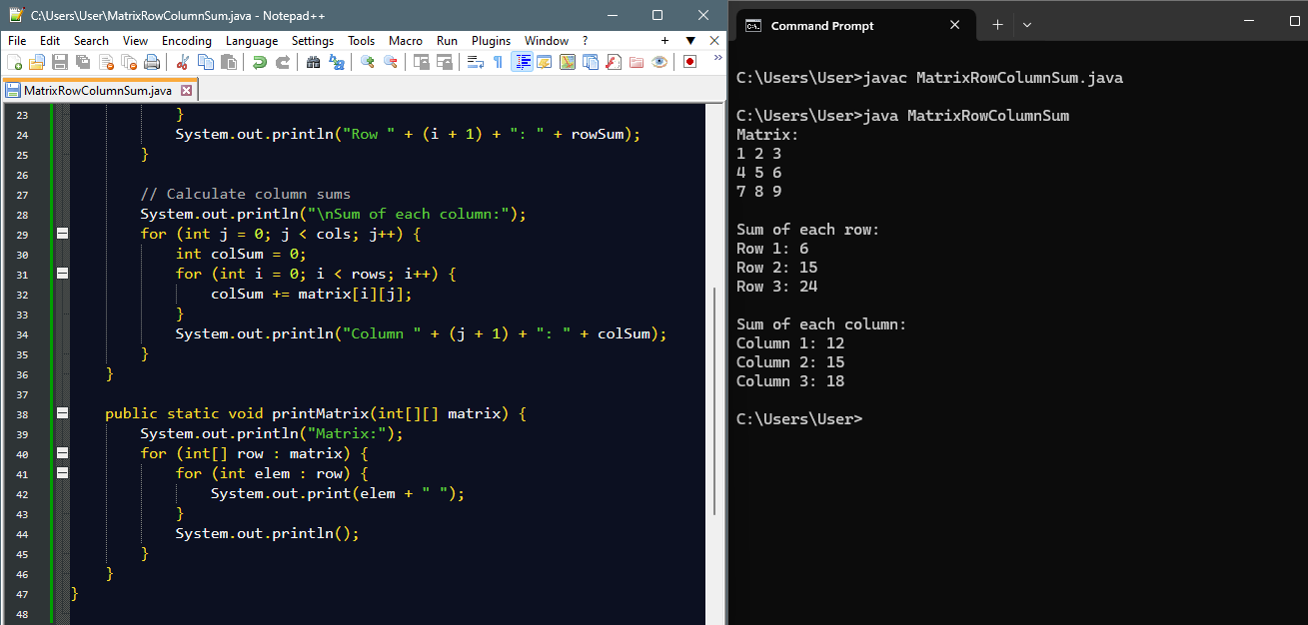

1. FindtheMaximumElementinaMatrix
   * Findthelargestelementinagivenmatrix.

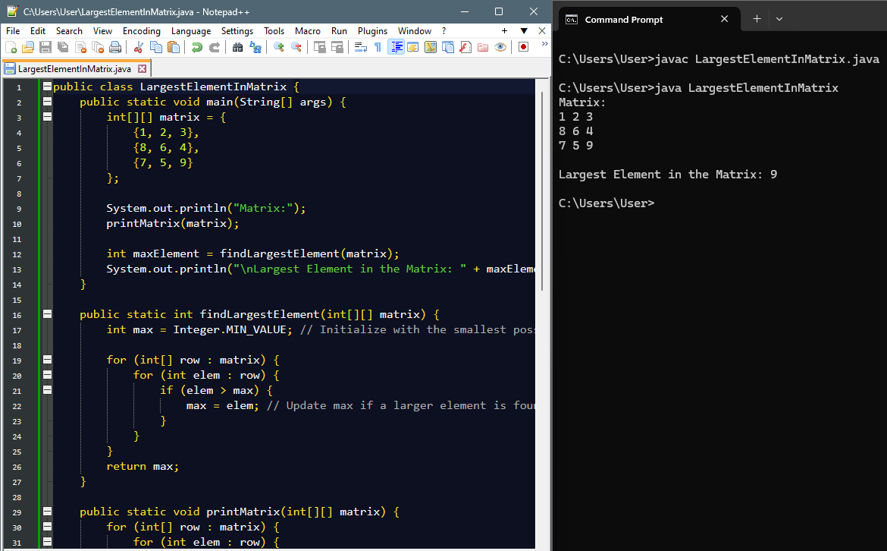

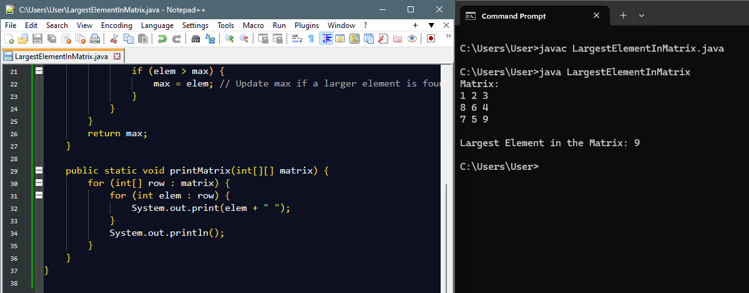

1. MatrixMultiplication
   * Multiplytwomatricesandreturntheresultantmatrix.

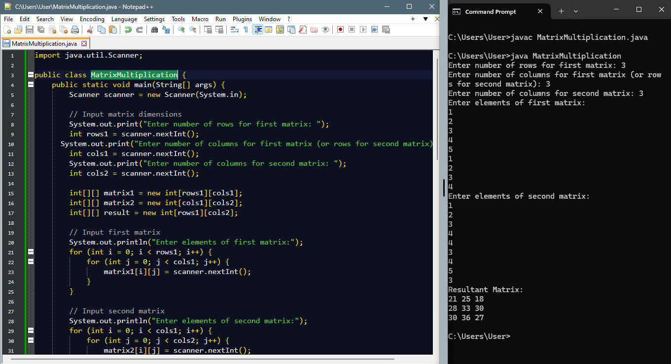

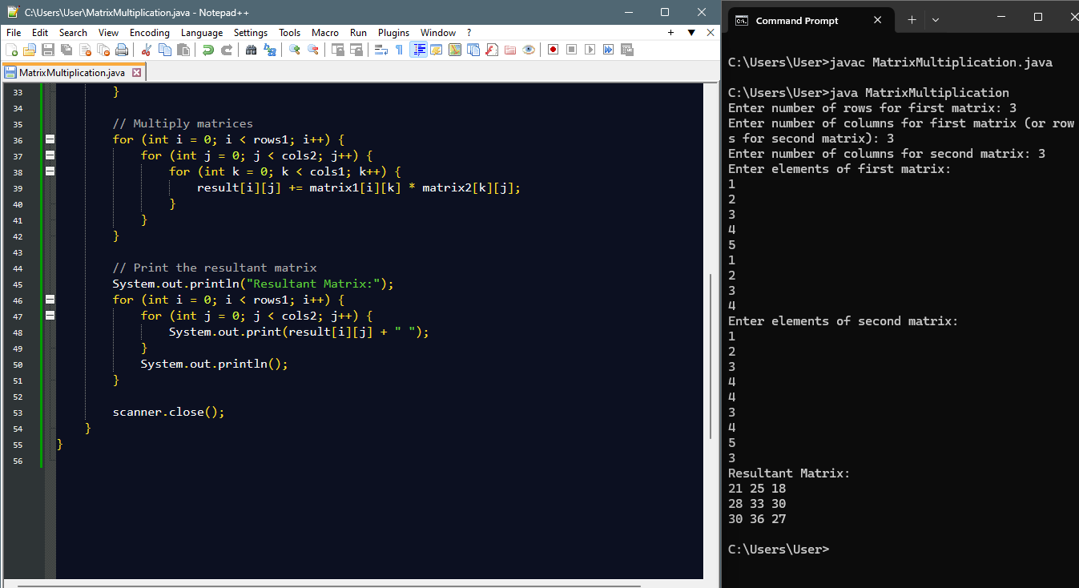

1. RotateaMatrixby90Degrees
   * RotateagivenNxNmatrixby90degreesclockwise.

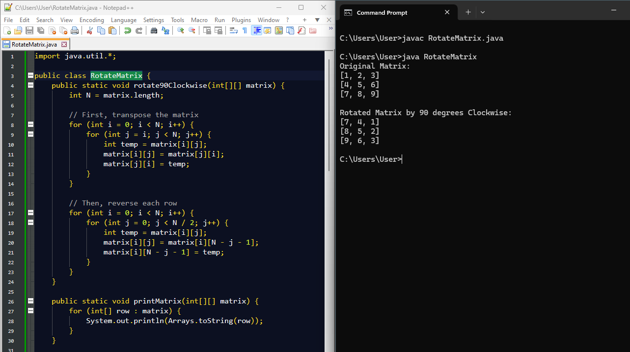

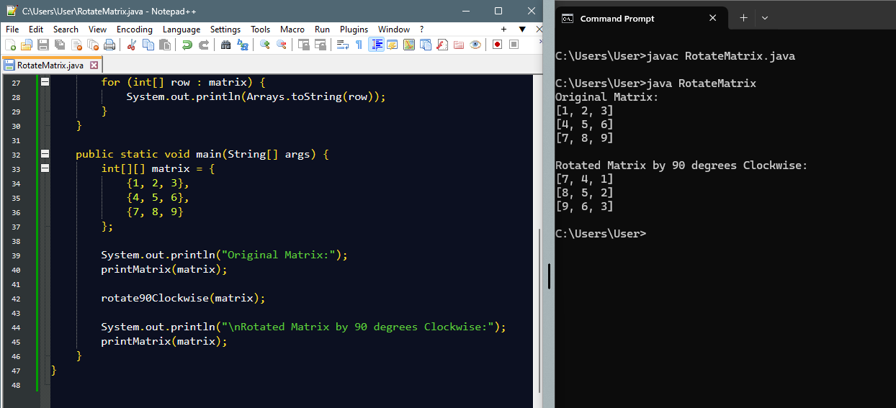

1. FindtheDiagonalSum
   * Computethesumofbothdiagonalsinasquarematrix.

